EXPERIMENT NO: 2

Aim: To study Version Control using GIT.

Theory:

Git is a distributed version control system (DVCS) designed to track changes in computer files, primarily used for source code management in software development.

Git is easy to learn and has a tiny footprint with lightning-fast performance. It outclasses SCM tools like Subversion, CVS, Perforce, and ClearCase with features like cheap local branching, convenient staging areas, and multiple workflows.

Some of the basic operations in Git are:

1. Initialize

2. Add

3. Commit

4. Pull

5. Push

Some advanced Git operations are:

1. Branching

2. Merging

3. Rebasing

Installation of GIT:

1) In Windows, download Git from https://git-scm.com/ and perform the straightforward

installation.

2) In Ubuntu, install GIT using $sudo apt install git. Confirm the version after installation

$git—version

Basic Git Commands with Terminal Output

**git config--global user.name "Mrunali"**

Sets your Git username globally across the system.

**git config--global user.email "mru@example.com"**

Sets your Git email address for all repositories.

**git init**

Initializes a new Git repository in the current directory

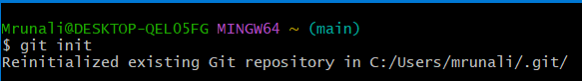

**git clone** [**https://github.com/mrunali-02/QRCODE-GENERATOR.git**](https://github.com/mrunali-02/QRCODE-GENERATOR.git)

Clones a repository from GitHub to your local system.

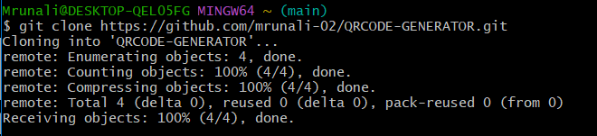

**git status**

Displays the state of the working directory and staging area.

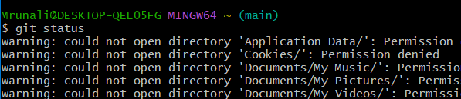

**Git add**

Stages all the changed files to be commited.

**git commit-m "Initial commit"**

Commit the staged changes with a message.

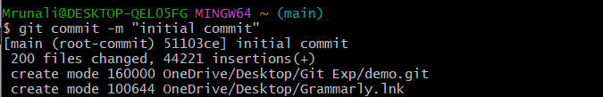

**git log**

Show the commit history for the current branch.

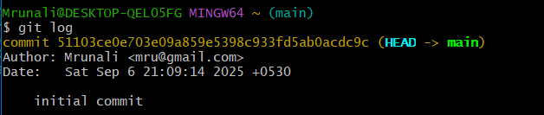

**git diff**

Displays changes not yet staged.

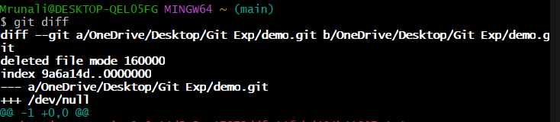

**git remote add origin https://github.com/mrunali-02/QRCODE-GENERATOR.git**

Adds a remote repository link to the local repository.

**git push-u origin main**

Pushes committed changes to the main branch of the remote repo

**git pull**

Fetches and integrates changes from the remote repo

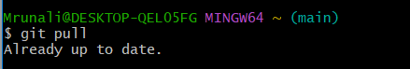

**git branch**

Lists all the branches in your repository.



**git branch feature**

Creates a new branch named 'feature'.

**git checkout feature**

Switches to the branch named 'feature'.

**git merge feature**

Merges changes from the 'feature' branch into the current branch

**git restore file.txt**

Restores a file in the working directory to its last committed state.

**git reset file.txt**

Un stages a file from the staging area.

**git reset--hard**

Resets the working directory and index to the last commit.

**CONCLUSION:**

Hence, we have successfully studied Version Control using Git.